Chapter Two: Literature Review
A personal scheduling system that reasons jointly about a user’s calendar, physiological state, and behavioural patterns must draw on several largely separate research traditions: information extraction, human-factors and fatigue modelling, the psychology of digital behaviour, multi-criteria decision theory, and constraint-based scheduling. No single body of literature addresses this integrated problem directly; consequently, this chapter surveys ten bodies of literature, one per system module, and structures the discussion so that a concept introduced in an earlier module is referred back to, rather than re-derived, wherever it recurs in a later one. The modules are discussed in the order that mirrors the logical flow of information through the system: raw input capture (Section 2.1); the scheduling substrate into which every other module ultimately writes (Section 2.2); the two behavioural-signal pipelines the system observes (Sections 2.3–2.4); the physiological models that estimate the user’s energetic and recovery state (Sections 2.5–2.6); the personalization layer (Section 2.7); the decision layer that fuses all preceding outputs into a single actionable score (Section 2.8); the rescheduling mechanism that reacts to change (Section 2.9); and, finally, a domain-specific application of the whole pipeline to gym planning (Section 2.10).
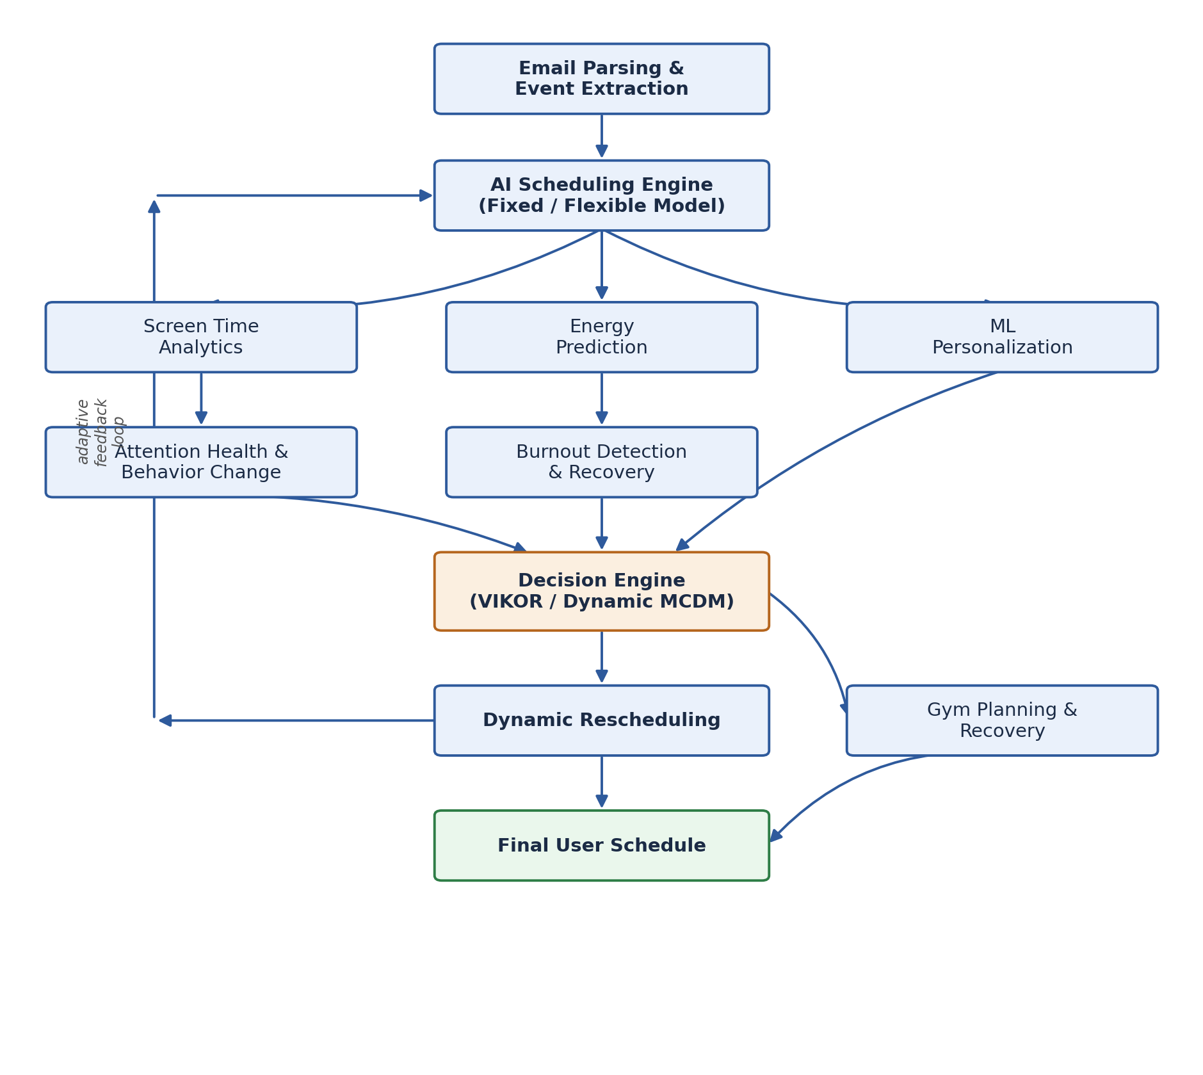
Figure 2.1. High-level module pipeline, from raw input capture through the Decision Engine to the final schedule, with Dynamic Rescheduling feeding an adaptive loop back into the AI Scheduling Engine.

2.1 Email Parsing and Event Extraction
Manual calendar entry is a persistent source of friction in personal scheduling systems, and university students in particular receive scheduling-relevant information through heterogeneous, unstructured channels: Gmail and Outlook messages, university administrative emails, meeting invitations, and reservation confirmations. Because this module sits at the entry point of the entire pipeline, any error or omission here propagates through every downstream module; automating extraction is therefore not merely a convenience feature but a precondition for the rest of the system to receive reliable input.
The foundational task decomposition is provided by Al-Kofahi et al.-style early work on automatic extraction of events and temporal expressions from email messages [1], which specifies that an event-bearing email should be decomposed into an event label, a date, a time, a location, and a set of participants. This decomposition, although proposed in an era that predates modern neural NLP, remains the correct specification of the sub-problems that must be solved; it is a task definition rather than a solving method. The literature review on named entity recognition [2] supplies the complementary, and considerably more current, half of the picture: a broad survey of extraction techniques — from rule-based and statistical sequence models such as conditional random fields through to modern transformer-based taggers — capable of identifying the date, time, location, person, organization, meeting, and course entities that the task decomposition in [1] calls for. The relationship between the two sources is therefore not one of competition but of specification and implementation: [1] defines what must be extracted, and [2] supplies the menu of models with which to extract it. The project adopts the field-level decomposition of [1] as the schema for its Event object and adopts from [2] the general recommendation to prefer contemporary transformer-based sequence labelling over the older rule-based methods the survey also documents, since the latter generalize poorly to the varied phrasing found in real student inboxes.
A second pair of papers, LayoutLM [3] and Donut [4], is reserved for a capability that is explicitly out of scope for the initial implementation but anticipated for university communications distributed as PDFs, scanned notices, or tabular attachments rather than as plain email text. LayoutLM [3] extends a BERT-style transformer with two-dimensional layout embeddings, so that the model reasons jointly over text content and its spatial position on a page; this requires an upstream OCR pass, and consequently inherits any OCR error as noise in its input. Donut [4] removes this dependency entirely by mapping a document image directly to structured output through a visual encoder-decoder architecture, avoiding OCR altogether at the cost of requiring a more specialized training procedure and offering less flexibility for arbitrary, previously unseen document layouts. The two papers therefore represent opposite ends of a trade-off between OCR-dependent robustness-through-established-tooling ([3]) and OCR-free but less mature end-to-end learning ([4]). The project does not adopt either model for its current implementation; both are retained at the concept level, to be revisited only if a later requirement to parse image-based or PDF-based university documents materializes.

Summary and Research Gap
The extraction literature surveyed here ([1]–[4]) is, individually, agnostic to what happens after an event is extracted: none of the four sources link the extracted structure to a prioritized, constraint-aware scheduler, and typical applications of this literature terminate at populating a plain calendar entry. The present module closes that gap by extending the output schema beyond the fields identified in [1] to include an explicit Priority Hint, which is propagated into the Decision Engine (Section 2.8) and consumed by the Dynamic Rescheduler (Section 2.9). This reframes event extraction as the first stage of a closed-loop scheduling system rather than as a standalone parsing utility, which is the gap this module is designed to address.

2.2 AI Scheduling Engine
The scheduling engine is the substrate onto which every other module ultimately writes: energy estimates, burnout risk, attention health, and extracted events are all, eventually, only useful insofar as they influence where a task is placed on the calendar. The central engineering problem is therefore not merely producing a feasible calendar, but doing so in a way that treats different task types with appropriate rigidity — an exam cannot move, but a study session can.
Three papers jointly define the module’s architecture, each addressing a distinct concern. The deployment and evaluation of SelfPlanner [5] contributes the overall architectural pattern: constraint-based scheduling combined with an iterative optimization layer, together with the notion of interruptible tasks, validated through an actual field deployment rather than simulation alone — a point of practical evidence that this class of architecture functions outside laboratory conditions. The formalization of a task’s temporal domain for intelligent calendar applications [6] contributes the data model: it specifies which attributes (earliest start, deadline, duration, and related temporal properties) must be known about a task before it can be scheduled at all. Personalized multi-activity scheduling of flexible activities [7] contributes the classification scheme that determines which of those well-defined tasks are allowed to move: University, Meetings, and Exams are treated as Fixed, while Study, Gym, Reading, Shopping, and Entertainment are treated as Flexible, so that the scheduler is permitted to relocate only the latter category.
Read together, these three sources compose into a single pipeline — task modelling using the schema of [6], Fixed/Flexible classification per [7], and constraint-based initial construction with iterative refinement per [5] — rather than into three competing proposals. Each has a specific limitation that motivates how the project departs from it. The temporal-domain formalism of [6] assumes the task attributes it enumerates are entered manually by the user; the project instead has these attributes inferred automatically by a language model from the output of the Email Parsing module (Section 2.1), which is an explicit and deliberate departure from the source paper’s assumption. The Fixed/Flexible dichotomy of [7] is coarse in that it determines whether a task may move at all, but not to which of several feasible slots it should move; this is precisely the gap that the Decision Engine (Section 2.8) is introduced to fill. SelfPlanner’s [5] specific optimization technique (referred to in the source literature as SWO) is domain-specific to its original deployment context and is not adopted in its exact form; only the general pattern of constraint-based construction followed by iterative repair is retained.

Summary and Research Gap
None of [5]–[7] incorporates a continuously updated model of the user’s physiological or attentional state when deciding where, among several feasible slots, a flexible task should be placed; each treats the user primarily as a source of calendar-availability constraints. The present architecture treats Fixed/Flexible classification and constraint-based placement, as established in this section, as the substrate on which the Decision Engine (Section 2.8) subsequently scores placement options using Energy, Burnout, and Attention Health signals — an integration that is present in none of the three sources considered individually.

2.3 Screen Time Analytics
Screen-time telemetry — usage duration, unlock counts, notification volume, app-level usage, and session duration — is a signal the operating system already collects, so using it imposes no additional logging burden on the user. Raw counters are not, however, directly actionable: the module’s purpose is to convert logs into interpretable behavioural features and, ultimately, a single score.
The literature here separates cleanly into a psychological pair, which establishes why the signal matters, and an engineering-oriented trio, which establishes how to compute it. On the psychological side, the systematic review of digital media use and cognitive function [8] establishes the empirical relationship between screen time — particularly short-video and social-media consumption — and attention, working memory, and executive function, which is the scientific justification for treating screen time as a predictor of attentional quality at all. The systematic review of problematic smartphone use [9] complements this by cataloguing the behavioural indicators of dysfunctional use, such as compulsive checking, overuse, and productivity loss, giving a taxonomy of what should be measured without itself specifying how the measurement should be computed from raw logs.
The engineering side supplies that missing computational bridge. The survey on mining smartphone usage patterns [10] operationalizes the indicators identified in [9] into concrete, computable features: daily usage, peak usage, night usage, app-switching frequency, and unlock frequency. The review of human activity recognition and behaviour analysis [11] is broader still, describing a general pipeline for converting a stream of user events into behavioural features; because it was developed primarily in the context of physical sensor data rather than phone-usage logs specifically, the project adopts only the general shape of its events-to-features pipeline, not any sensor-specific technique it documents. Finally, the work on learning to personalize recommendations based on user behaviour [12] supplies the idea, drawn from a recommender-systems context, of collapsing a multi-dimensional behavioural log into a single interpretable score rather than presenting the user with a raw usage dashboard; only this scoring philosophy is reused, not the underlying recommendation-model architecture, which targets a different problem entirely.
The pattern that emerges — psychology papers establishing the validity of a signal, engineering papers establishing the pipeline that computes it — recurs throughout this review and is made explicit here for the first time so that it can be referred back to rather than re-explained in Sections 2.4 and 2.6.

Summary and Research Gap
Existing usage-mining work ([9]–[12]) stops at producing descriptive features or a generic score; none of it is, in the surveyed material, connected to a downstream scheduling decision. The Screen Time Score produced by this module is explicitly designed as an input feature to the Attention Health Module described next (Section 2.4), closing the gap between passive usage analytics and an actionable scheduling response that is absent from [9]–[12] taken individually.

2.4 Attention Health and Behaviour Change
Chronic overuse of short-form digital media degrades sustained attention, and a scheduler that ignores this will continue to assign long deep-work sessions the user can no longer realistically sustain. This module therefore needs both a way of quantifying attentional health and a way of intervening constructively once it declines.
Two validated self-report instruments anchor the measurement side: the Smartphone Addiction Scale [13] and the Internet Addiction Test [14] are widely used, psychometrically validated questionnaires that yield a severity score rather than a clinical diagnosis. This score-not-diagnosis framing is adopted deliberately and consistently with the stated intent of the instruments themselves, since the project does not attempt to diagnose any condition. Because these instruments are administered only periodically, they are combined with two sources already introduced in Section 2.3: the behavioural indicators from the problematic-smartphone-use review [9] and the screen-time – attention relationship established in [8], both of which are reused here as components of a composite score rather than re-derived.
A separate cluster of intervention-oriented papers governs how the system responds once attentional health is found to be low. The meta-analysis on implementation intentions and goal achievement [15] provides strong evidence that if-then planning — for example, “if the lecture ends, then study for thirty minutes” — is among the most effective techniques for reducing procrastination, and is adopted directly as the template for the adaptive tasks the system generates. The systematic review of habit formation and behaviour change [16] supports habit substitution over a longer horizon — replacing short-video consumption with walking, reading, gym attendance, or meditation — and is adopted as the strategy behind the system’s activity recommendations. The systematic review of digital detox interventions [17] finds that gradual reduction consistently outperforms abrupt cessation, and this finding is adopted as the general tone of the system’s interventions: nudges rather than blocks. These three papers are complementary rather than overlapping: [15] governs when a nudge fires, [16] governs what alternative activity is proposed, and [17] governs how strongly any given intervention is enforced.
On the computational side, the survey on user modelling and adaptive personalization [18] supplies the feature-fusion methodology used to merge the three heterogeneous sources — questionnaire, behavioural, and screen-time — into a single Attention Health Score, while the scoring philosophy from [12] and the events-to-features pipeline pattern from [11], both already introduced in Section 2.3, are reused here applied to behavioural events (task completion, skip rate, rescheduling frequency, focus-session count) rather than to raw usage logs.
The principal limitation of [13] and [14] is that, being periodic self-report instruments, neither can capture day-to-day variation on its own, which is precisely why the module maintains three parallel channels — questionnaire, behaviour, and screen time — rather than relying on the questionnaire alone. Sources [15]–[17], being behaviour-change findings from psychology rather than algorithms, cannot be adopted as code; they are instead operationalized as adaptive rule triggers within the system.

Summary and Research Gap
The addiction-scale literature ([13], [14]) and the behaviour-change intervention literature ([15]–[17]) belong to separate research communities and are not, in the material surveyed, connected to a real-time scheduling system; applications of [13] or [14] typically report a static score rather than one that feeds an adaptive session-length mechanism. The present module fuses questionnaire, behavioural, and screen-time channels into a single Attention Health Score and passes it directly to the Decision Engine (Section 2.8), where it deterministically shortens a planned Deep Work block into a Pomodoro-style interval — an integration not present in any of the individually surveyed sources.

2.5 Energy Prediction
Cognitive and physical capacity fluctuates predictably across the day and with accumulated activity; scheduling a demanding task at a low-capacity point wastes the slot and increases the likelihood of error. The system therefore requires a numeric estimate of current capacity rather than a fixed heuristic such as assuming mornings are universally optimal.
The mathematical backbone of the module is Borbély’s two-process model of sleep regulation [19], which combines a homeostatic sleep-pressure term, Process S, that rises monotonically the longer a person remains awake, with a circadian term, Process C, an oscillatory rhythm with an approximately twenty-four-hour period. The project adopts the additive combination of these two processes as the base structure of its Energy Score. A naive application of [19] alone would assume the same circadian phase for every user, which the empirical study of time-of-day effects on cognitive performance [20] shows to be incorrect: peak cognitive performance timing is chronotype-dependent, with morning, evening, and intermediate types identified in the literature. The project therefore adopts [20] specifically to personalize the phase of Process C per user, computing an individual Peak Focus Window rather than a single population-wide peak.
A second refinement concerns fatigue accumulation. The meta-analysis on mental fatigue’s impairment of physical and cognitive performance [21], together with the closely related work on fatigue modelling in human performance and its companion mathematical treatment of fatigue and recovery [22], [23] — the latter two of which are given under the same source reference in the collected literature and are therefore discussed jointly here rather than treated as fully independent contributions — establish that fatigue is driven by the accumulated history of a day’s activities (study hours, meetings, work duration, exercise), not solely by the duration of the immediately preceding task. This motivates an Accumulated Fatigue term computed from Activity History rather than from the last task alone, and further motivates a Recovery Score term reflecting that performance returns along a curve after sleep, a break, or a nap, rather than resetting instantaneously.
The remaining sources address how to combine the preceding terms into a single composite figure. The work on predicting cognitive performance from sleep, circadian rhythm, and wakefulness, together with its companion bio-mathematical treatment [24], [26] — again given under the same reference in the collected literature and discussed jointly — and the SAFTE model [25] both attempt exactly this combination; SAFTE is additionally notable for introducing the sleep-reservoir metaphor, in which accumulated sleep debt is represented as a depletable and rechargeable pool, and for being one of the most widely used human-performance-prediction models in operational fatigue-risk-management settings such as aviation and defence. The project adopts the general shape of SAFTE’s Current-Effectiveness-Score computation and the sleep-reservoir bookkeeping idea, but explicitly does not adopt SAFTE in full, since its parameterization is calibrated for shift-work and extreme sleep-deprivation scenarios rather than a typical student day; the combination logic is retained while the specific coefficients must be re-fit to the target population. Similarly, the original two-process model [19] was derived under controlled sleep-laboratory conditions rather than from free-living, smartphone-derived data, so only its combination logic, not its exact parameterization, is carried forward, and the meta-analytic effect sizes reported in [21] are treated as indicative of the shape of a fatigue-decay curve rather than as fixed, directly portable coefficients.

Summary and Research Gap
The human-performance models surveyed here ([19]–[26]) were built for operational contexts — aviation, shift work, controlled sleep studies — that assume dedicated sensor or self-report input, and none of them is, in the material reviewed, integrated with a task scheduler consuming the resulting score in real time. This module adapts the combination logic of these models into a Current Energy Score, computed on a zero-to-one-hundred scale from ordinary calendar, activity, and screen-time signals, and feeds it directly into the Decision Engine (Section 2.8) and Scheduler, closing the gap between physiological performance modelling and everyday personal-scheduling software.

2.6 Burnout Detection and Recovery
Distinguishing transient fatigue, addressed in Section 2.5, from the longer-horizon phenomenon of burnout matters because the appropriate system response differs substantially: a short break addresses fatigue, whereas sustained burnout requires workload reduction and rescheduling over days rather than minutes.
The review of burnout theory and measurement [27] is foundational in that it distinguishes burnout from mental fatigue and from stress, and surveys existing measurement approaches; it is adopted for definitional clarity and, more importantly, for supporting the project’s explicit design decision to compute a Burnout Risk Score rather than to attempt anything resembling clinical diagnosis. The systematic review of predictors of occupational burnout, synthesizing eighty-five studies [28], identifies high workload, poor recovery, negative job attitude, poor coping, and lack of leisure as the dominant predictors; the project adopts the subset that is measurable from passively sensed calendar and behavioural telemetry — Mental Workload, Recovery, Continuous Work Duration, and Break Quality — while deliberately excluding negative job attitude and poor coping, since both require attitudinal self-report data outside the scope of passive sensing. The review of psychosocial working conditions and burnout [29] reinforces two aggregate factors from this subset, Continuous Overload and Recovery Deficit, which the project adopts as named terms within its risk-scoring logic. The meta-analysis on interventions to alleviate burnout symptoms [30] ranks breaks, recovery time, and workload reduction above simply persisting through a demanding period, and this ranking is adopted as the intervention policy triggered when Burnout Risk is high: reschedule, reduce difficult tasks, increase break allocation, suggest a leisure activity, and suggest earlier sleep, rather than merely flagging the elevated risk to the user.
On the computational side, the survey on machine learning in burnout prediction [31] is reviewed specifically for its treatment of how workload, recovery, stress, and history are converted into model features; the project deliberately does not adopt machine learning at this implementation stage, taking only this feature-framing idea. The review of machine-learning-assisted human fatigue detection [32] contributes the Recovery Function concept — the principle, already introduced for Energy Prediction in Section 2.5, that risk decreases progressively rather than discontinuously following sleep, a break, or a weekend — applied here to Burnout Risk rather than to the Energy Score. The comprehensive review of approaches to detect fatigue using machine learning techniques [33] taxonomizes detection methods into rule-based, mathematical-model, machine-learning, and deep-learning tiers; the project positions its implementation explicitly at the rule-based and mathematical-model tiers of this taxonomy, deliberately excluding the machine-learning and deep-learning tiers for the current phase.
As in Sections 2.3 and 2.5, the psychology-oriented sources ([27]–[30]) establish what to measure and why, while the engineering-oriented sources ([31]–[33]) establish how comparable prior work has computed such a score, of which only the non-machine-learning tier is adopted. The principal limitation of [28] is that its synthesis, while broad, is occupational and workplace-focused rather than student-specific, so several of its predictors do not map cleanly onto a university context and are excluded on that basis; the principal limitation of adopting only the rule-based and mathematical tiers identified in [33] is reduced predictive sophistication relative to the machine-learning tier the same survey documents, which the project accepts as a deliberate complexity-versus-explainability trade-off given the absence, at this stage of the project, of a labelled dataset large enough to train a burnout-detection model responsibly.

Summary and Research Gap
Occupational-health literature ([27]–[30]) defines burnout risk factors and effective interventions without being designed for continuous computation from passively sensed data, while the machine-learning-based detection literature ([31]–[33]) assumes the availability of large labelled datasets that a project at this stage does not possess. By combining the risk-factor definitions from the psychological literature with a rule-based and mathematical computation strategy, per the lower tiers of the taxonomy in [33], and the Recovery Function idea from [32], the module produces a Burnout Risk Score that is explainable, computable without a training corpus, and consumable in real time by the Decision Engine (Section 2.8) — a practical integration gap that the surveyed literature, taken individually, does not close.

2.7 ML Personalization
A single fixed rule set cannot capture that one user studies best late at night while another is most productive at dawn, nor that the same user’s priorities shift between an examination week and an ordinary week. The system therefore requires a personalization layer capable of adjusting scheduling parameters — not the underlying rules themselves — to the individual and to the individual’s current context.
The work on adaptive user modelling with long- and short-term preferences [34], together with its more detailed exposition of the same underlying user-profile design [38] — which the collected material presents as an elaboration of [34] rather than as an independent contribution, and which is accordingly discussed jointly here rather than double-counted — contributes both the long-term-versus-short-term preference split (a generally night-active user versus the same user’s temporarily exam-focused week) and a concrete user-profile feature set: Preferred Focus Hours, Average Sleep, Productive Days, Average Session Length, and Break Frequency. The project adopts this feature set as its personalization schema, with the additional observation that Average Focus Duration can be derived directly from the Screen Time Analytics module (Section 2.3) — for instance, from how often the phone is checked during study sessions — rather than requiring separate self-report.
The work on personalized adaptive meta-learning for cold-start user preference prediction [35] addresses how to personalize a system before sufficient usage history exists. The project adopts only the concept of a staged transition — a fixed rule engine for approximately the first two weeks, followed by gradual learning from accumulated history — explicitly without adopting the meta-learning algorithm itself, since genuine meta-learning requires a distribution of tasks across many users that is unavailable at this stage of the project. The work on adaptive preference arithmetic [36] argues that user preferences are context-dependent rather than fixed — study becomes dominant during an examination period and gym priority returns to normal afterward — and is adopted as the conceptual justification for time-varying preference weights rather than a static profile. The work on personalized adaptation via in-context preference learning [37] demonstrates online adaptation without retraining a model, contributing the idea of a weekly update cadence; the project adopts this cadence — a weekly re-estimation of personalization parameters from the week’s accumulated data — without adopting the specific in-context-learning mechanism itself, which targets large language models rather than lightweight parameter updates.
Read together, [34] and [38] specify what is personalized, [36] explains why it must change over time, and [35] and [37] each propose a when-and-how update mechanism at opposite ends of a complexity spectrum: fast meta-learning-based adaptation for brand-new users versus retraining-free, in-context adaptation for established ones. The project synthesizes a middle path between these extremes: rule-engine defaults at cold start, informed by the staged-transition concept in [35]; weekly parameter updates thereafter, at the cadence suggested by [37]; governed throughout by the profile schema of [34] and [38]; and adjusted for context shifts as motivated by [36]. Full meta-learning [35] and in-context learning with a large model in the loop [37] both assume infrastructure and data volume disproportionate to a graduation project’s scale, which is why only the underlying concepts, rather than the specific algorithms, are carried forward from either source.
The project also extends beyond any individual cited approach by introducing a periodic, explicit user-facing feedback question — essentially, whether a recent adjustment was well received — whose answer is intended to be modelled as a lightweight reinforcement signal, so that an undesirable automatic adjustment can be corrected rather than silently persisted. This safeguard is not present in [34]–[38] and is best understood as an original design addition motivated by, rather than directly drawn from, this literature.

Summary and Research Gap
The personalization literature surveyed here is drawn from general-purpose recommender-systems research ([34]–[38]) rather than from scheduling or wellbeing applications specifically, and none of the surveyed papers closes the loop with explicit user feedback to correct a poor automatic adjustment, relying instead on implicit signals or offline evaluation. The present module closes this gap by pairing the adopted profile-and-update-cadence design with a periodic explicit feedback question treated as a reinforcement-learning signal, giving the personalization layer a correction mechanism that the source literature does not provide.

2.8 Decision Engine
Once Energy (Section 2.5), Burnout Risk (Section 2.6), and Attention Health (Section 2.4) have each produced a separate score, and every incoming task (Sections 2.1–2.2) carries its own deadline and importance, the system requires one principled way of converting several, sometimes conflicting, criteria into a single ranking. This is a textbook multi-criteria decision-making problem rather than a simple weighted sum, because the criteria differ in units, scale, and directionality, and because a naive average risks silently trading off a dangerous outcome on one criterion against comfortable performance on another.
The application of the VIKOR method to deadline-based task scheduling using multi-criteria decision making [39] supplies the core ranking algorithm. VIKOR normalizes each criterion and, for every candidate alternative, computes an aggregate group-utility measure, commonly denoted S, approximating a weighted sum of each criterion’s normalized distance from its ideal value, together with an individual-regret measure, denoted R, equal to the single worst normalized distance across all criteria for that alternative. These two measures are then combined into a compromise ranking index, Q, that balances overall performance against worst-case performance, so that an alternative which is merely good on average but very poor on one criterion is penalized rather than allowed to average out to an acceptable score. This property is directly relevant to the project: a task placement that fits a deadline well but would push Burnout Risk to a dangerous extreme should not be ranked as acceptable simply because its other criteria are favourable, and the R term in VIKOR is precisely the mechanism that prevents this. The project adopts the S, R, and Q computation as the core of its Decision Score.
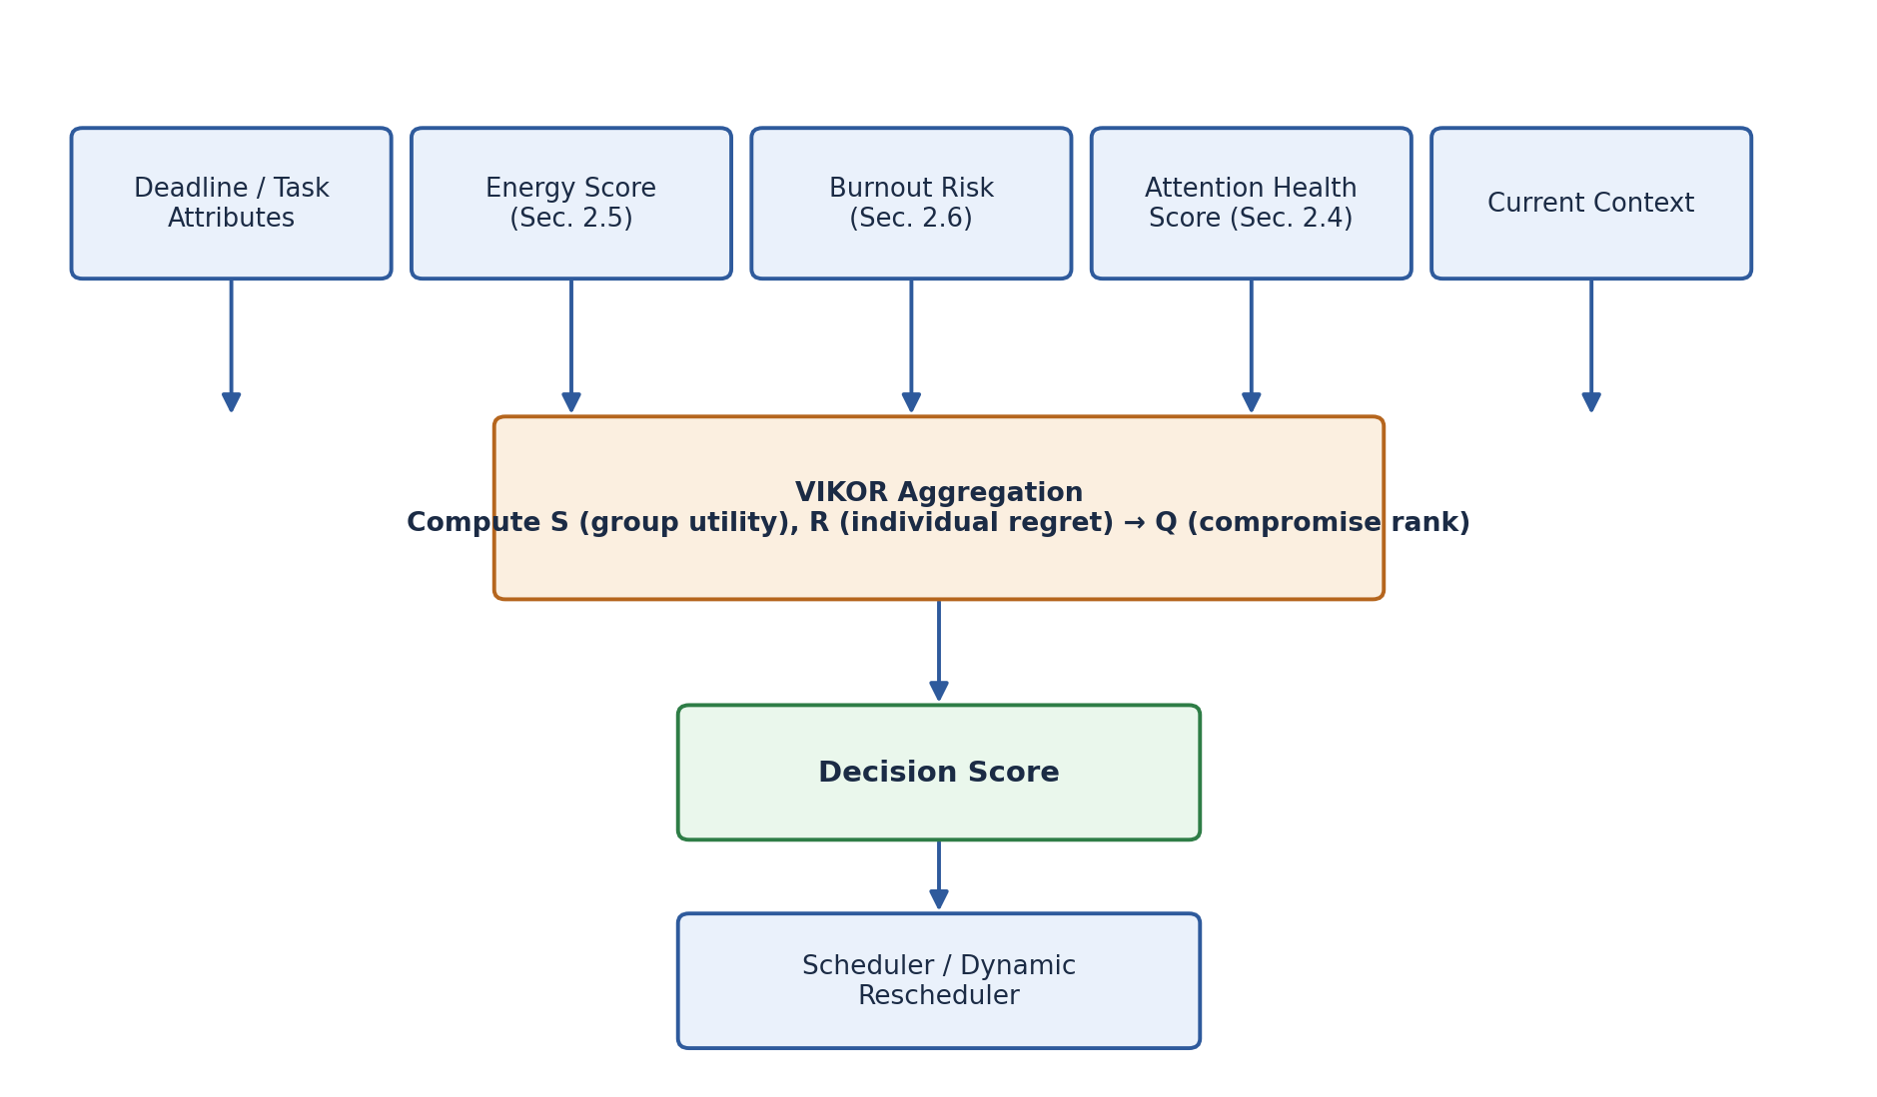
Figure 2.2. Internal structure of the Decision Engine: five heterogeneous criteria are normalized and aggregated by VIKOR into a single compromise Decision Score, which is consumed by the Scheduler and the Dynamic Rescheduler.
Two further papers reinforce a specific operating principle rather than proposing an alternative algorithm: the dynamic multi-criteria scheduling algorithm of 2024 [40] and the dynamic decision-support work applying multi-criteria decision making to situational awareness for drones [41] both demonstrate, in different application domains, that priority should be recomputed at each decision point rather than stored as a fixed value — a Dynamic Weighted Scoring approach. Because [41] applies the same general principle in a different domain rather than introducing a competing method, it is treated as corroborating evidence for the recompute-on-context-change design decision already motivated by [40], and the project adopts this principle directly: the Decision Score is recalculated on demand whenever relevant context changes, rather than cached.
The comparison of multi-criteria decision analysis methods [42], which reviews more than two hundred such methods including AHP, TOPSIS, VIKOR, and PROMETHEE, is used specifically to justify selecting VIKOR over its principal alternatives for this project’s requirements. AHP depends on labour-intensive pairwise comparison matrices that are poorly suited to a system that must recompute its ranking automatically and continuously, and TOPSIS lacks VIKOR’s explicit regret term balancing average performance against worst-case criterion performance — a property this project specifically needs, as discussed above. VIKOR is therefore adopted not by default but as the method best matched to a continuous, automatic, regret-sensitive requirement, per the guidance in [42].
Two remaining sources contribute concepts rather than algorithms. Goal-oriented requirements engineering, as embodied in the KAOS framework [43], contributes only the high-level idea that a large goal decomposes into progressively smaller, executable tasks; the project adopts this decomposition philosophy for how tasks enter the Decision Engine, without adopting any part of the formal specification or verification apparatus that KAOS itself provides for requirements engineering, since that apparatus targets a different problem. The survey on explainable artificial intelligence [44] contributes the design principle that every automatic decision should be accompanied by a short natural-language justification — for example, explaining that a task is being prioritized now because a deadline is two days away — rather than surfacing only an opaque numeric score. Because the Decision Score itself is already a transparent, formula-based computation rather than a black-box model, the project does not adopt any specific post-hoc explanation technique surveyed in [44], such as SHAP or LIME; only the general design principle of interpretability is carried forward.
The six sources in this section therefore address six different concerns around a single central decision — what to rank, how to rank it, when to re-rank it, why that ranking method specifically, how tasks are decomposed before reaching it, and how its output is communicated — rather than proposing six competing solutions to the same concern. The principal limitation shared by [39]–[41] is that VIKOR, like all multi-criteria decision-making methods, requires criterion weights to be specified in advance, and none of the surveyed sources resolves how those weights should themselves be tuned; this is left as an open engineering parameter to be calibrated empirically. Similarly, the comparison in [42] is qualitative, method-agnostic guidance rather than an empirical benchmark run on this project’s specific criteria, so the choice of VIKOR, while well justified in principle, should still be validated empirically against alternatives such as TOPSIS during system evaluation.

Summary and Research Gap
Multi-criteria decision-making scheduling literature ([39]–[42]) is typically demonstrated on manufacturing, logistics, or situational-awareness domains, not on personal or academic scheduling that must weigh a person’s physiological and behavioural state alongside conventional criteria such as deadline and importance; none of the surveyed papers incorporates human-factors scores of the kind produced in Sections 2.4–2.6, nor pairs its ranking output with an explicit natural-language rationale as suggested in [44]. The Decision Engine closes this gap by extending VIKOR’s criteria set to include Energy, Burnout Risk, and Attention Health Score alongside Deadline and Context, and by attaching an explanation, motivated by [44], to every decision — producing a Decision Score that is simultaneously physiologically aware and interpretable, a combination absent from the cited multi-criteria decision-making literature.

2.9 Dynamic Rescheduling
Real calendars change continuously: a class is cancelled, a meeting is added, a task is missed. Rebuilding the entire schedule after every such event is both computationally wasteful and needlessly disruptive to the user, so the system requires a principled way of updating only the affected portion of the plan.
The survey of rescheduling techniques in dynamic scheduling environments [45] enumerates the categories of disruption that can trigger a reschedule — reinterpreted in this project’s context as, for example, a newly announced exam, a missed gym session, or a newly added meeting — and distinguishes Full Rescheduling, in which the entire plan is rebuilt, from Partial Rescheduling, in which only the affected region is repaired. The project adopts the principle that a new event should trigger a partial repair rather than a full rebuild. The work on dynamic rescheduling in response to unexpected events using constraint satisfaction [46] operationalizes this principle: when a task is cancelled, delayed, or a new deadline appears, the constraint-satisfaction formulation redistributes only the tasks it must, while respecting existing constraints. The project adopts this technique directly, together with the instruction — echoing the Fixed/Flexible classification introduced in Section 2.2 — that Fixed tasks must never be moved and that the number of Flexible tasks affected by any single repair should be minimized. The survey and taxonomy of predictive-reactive scheduling [47] formalizes the two-phase architecture within which both of the preceding sources operate: a Predictive phase that builds the baseline schedule, and a Reactive phase that repairs it after a disruption. The project adopts this two-phase framing as its overall architecture, with the AI Scheduling Engine (Section 2.2) together with the Decision Engine (Section 2.8) performing the predictive phase, and the module described here performing the reactive phase.
The three sources operate at decreasing levels of abstraction — [45] answers when and what kind of rescheduling is warranted, [46] answers how, algorithmically, to perform a partial repair, and [47] answers what overall architecture the repair fits into — and were selected specifically because they compose into a single coherent description of the module rather than because they compete on a shared benchmark. Because [45] and [47] are surveys, neither specifies an executable algorithm on its own and each must be paired with a concrete technique such as [46]. A further limitation is that the constraint-satisfaction formulation in [46] assumes its constraints are known and static at the moment of repair, whereas in this project several relevant constraints — the Energy Score and Burnout Risk in particular — are themselves outputs of other modules that change continuously over the course of a day; this is not addressed directly in the reactive-scheduling literature surveyed here, and the project must instead re-query those modules immediately before each repair rather than treating their outputs as fixed inputs.

Summary and Research Gap
Predictive-reactive scheduling and constraint-based repair are well established in industrial and manufacturing contexts ([45]–[47]) but are not, in the surveyed material, connected to physiologically driven constraints that themselves drift over the course of a day as energy declines or burnout accumulates. This module extends the reactive-scheduling pattern of [47] and the constraint-satisfaction repair technique of [46] by re-evaluating the Decision Engine’s physiological criteria at each rescheduling trigger, rather than recomputing only calendar feasibility, integrating dynamic-scheduling theory with the physiological modelling introduced in Sections 2.5 and 2.6.

2.10 Gym Planning and Recovery
Fitting resistance training around an academic calendar while respecting muscle-recovery constraints and daily energy fluctuation is a constrained scheduling problem in its own right, but one that can reuse almost the entire scheduling and decision infrastructure already established in earlier sections rather than requiring new algorithmic machinery.
The domain-specific constraint set is supplied by the International Union of Strength and Conditioning Associations’ position stand on resistance training for muscle hypertrophy [48], an evidence-based sports-science consensus document specifying minimum recovery intervals between sessions targeting the same muscle group, training-frequency recommendations, and training-volume guidelines. The project adopts this constraint set directly — minimum rest per muscle group and avoidance of scheduling two heavily fatiguing muscle groups on consecutive days — as hard constraints fed into the constraint-based scheduler already described in Section 2.2. Two sources introduced earlier are reapplied here rather than re-derived: the ETH Zurich Fixed/Flexible split [7] is reapplied with University, Meetings, and Exams as Fixed and Gym as Flexible, and SelfPlanner’s constraint-based, iteratively repaired scheduling pattern [5] is reapplied to the specific case of redistributing a gym session when a workout is missed, a meeting is added, or study times change. Neither reuse constitutes a new algorithmic contribution; the contribution of this section lies in applying machinery already justified in Section 2.2 to a new domain.
The systematic review of intelligent scheduling methods for job-shop scheduling problems [49] surveys constraint satisfaction, heuristic scheduling, and metaheuristic approaches. The project adopts only the constraint-based-scheduling framing from this survey — encoding recovery, user-fixed days, and study or work schedule as hard constraints — and explicitly does not adopt the heuristic or metaheuristic search methods the same survey documents, since the constraint set involved here is small enough that direct constraint-based placement, consistent with the pattern already used in Sections 2.2 and 2.9, is sufficient without a heuristic search layer.
This module is, from a purely literature-based standpoint, the least novel of the ten discussed in this chapter, since its scheduling mechanics are inherited wholesale from Sections 2.2 and 2.9; its distinguishing contribution is domain content — the muscle-group recovery rules from sports science [48] — layered onto machinery already justified earlier in the review, together with a consultation of the Energy Prediction module (Section 2.5) to decide whether to reduce the intensity of, or postpone, rather than cancel outright, a session when predicted energy is low. Source [48] is a sports-science consensus document rather than a scheduling paper, so it supplies constraints but no algorithmic guidance, which is precisely why it must be paired with [49], [5], and [7]; conversely, [49] contains no sports-science content, so neither source is sufficient in isolation. A limitation still under active development at the time of writing is the precise interaction between a user’s self-reported training level — novice, intermediate, or advanced — and the recovery-interval constraints drawn from [48], which is not yet fully specified in the current design.

Summary and Research Gap
Sports-science recovery guidelines such as [48] are not, in the literature surveyed, integrated with personal-calendar scheduling systems, and general-purpose scheduling surveys such as [49] do not encode domain-specific physiological recovery constraints; the constraint-based, iteratively-repaired scheduling machinery from Sections 2.2 and 2.9 was, in its original sources ([5], [7]), demonstrated on generic academic and work activities rather than on resistance training specifically. This module closes that gap by instantiating the already-adopted scheduling machinery with hypertrophy-training recovery constraints from [48] and by additionally consulting the Energy Prediction module (Section 2.5) to choose between full training, reduced-intensity training, and postponement — an application-level integration present in neither the sports-science nor the scheduling literature considered separately.

2.11 Cross-Module Mapping Summary
The ten modules discussed above draw on a shared pool of forty-nine sources with substantial reuse across module boundaries, and several papers contribute a reusable algorithm rather than only background motivation. Table 2.1 summarizes the three clearest cases in which a single named algorithm from the reviewed literature is carried, largely intact, into a specific computational component of the system.
Table 2.1. Algorithms adopted directly from the reviewed literature.
Ref. | Module | Algorithm | Used In Project
[39] | Decision Engine | VIKOR (Multi-Criteria Decision Making) | Computation of the Decision Score
[25] | Energy Prediction | SAFTE (Sleep, Activity, Fatigue and Task Effectiveness) | Current-Effectiveness computation within the Energy Score
[45] | Dynamic Rescheduling | Constraint-Based Partial Repair | Dynamic Scheduler / Rescheduler

Beyond these three single-algorithm cases, most modules are supported by a cluster of several papers rather than by one dominant source, consistent with the comparative treatment given throughout this chapter. Table 2.2 lists the two modules with the largest such clusters, Decision Engine and Burnout Detection and Recovery, each of which required the joint contribution of every paper listed to fully justify the module’s design.
Table 2.2. Modules supported by a multi-paper cluster rather than a single source.
Module | Main Papers
Decision Engine | [39], [40], [41], [42], [43], [44]
Burnout Detection and Recovery | [27], [28], [29], [30], [31], [32], [33]

Finally, Table 2.3 restates, module by module, the primary literature cluster consulted and the concrete computational output that literature is used to produce, giving a single point of reference that connects the discussion in Sections 2.1–2.10 directly to the System Design chapter that follows.
Table 2.3. Module-to-output mapping.
Module | Papers | Output
Email Parsing and Event Extraction | [1]–[4] | Event Object
AI Scheduling Engine | [5]–[7] | Weekly Schedule
Attention Health and Behavior Change | [13]–[18] | Attention Health Score
Energy Prediction | [19]–[26] | Energy Score
Burnout Detection and Recovery | [27]–[33] | Burnout Risk Score
Decision Engine | [39]–[44] | Decision Score

References
The following list gives the sources cited throughout this chapter in IEEE numbered style, corresponding to the collected literature assembled for each module. Where the source material did not include complete bibliographic metadata (author names, journal, volume, or page numbers), the entry below reflects the title, indicative year, and URL as collected; these entries should be completed with full bibliographic detail from the original publications before final thesis submission.
[1] "Automatic Extraction of Events and Temporal Expressions from Email Messages." [Online]. Available: https://aclanthology.org/W05-0407/
[2] "Named Entity Recognition: A Literature Review." [Online]. Available: https://arxiv.org/abs/1812.09449
[3] "LayoutLM: Pre-training of Text and Layout for Document Image Understanding." [Online]. Available: https://arxiv.org/abs/1912.13318
[4] "Donut: Document Understanding Transformer without OCR." [Online]. Available: https://arxiv.org/abs/2111.15664
[5] "Deployment and Evaluation of SelfPlanner, an Automated Individual Task Management System," 2011. [Online]. Available: https://www.researchgate.net/publication/220541685_Deployment_and_evaluation_of_SelfPlanner_an_automated_individual_task_management_system
[6] "Defining a Task’s Temporal Domain for Intelligent Calendar Applications." [Online]. Available: https://www.researchgate.net/publication/220828298_Defining_a_Task's_Temporal_Domain_for_Intelligent_Calendar_Applications
[7] "Personalized Multi-Activity Scheduling of Flexible Activities," ETH Zurich Research Collection. [Online]. Available: https://www.research-collection.ethz.ch/handle/20.500.11850/254413
[8] "Digital Media Use and Cognitive Function: A Systematic Review." [Online]. Available: https://pmc.ncbi.nlm.nih.gov/articles/PMC10852174/
[9] "Problematic Smartphone Use: A Systematic Review of Existing Literature." [Online]. Available: https://pmc.ncbi.nlm.nih.gov/articles/PMC6035022/
[10] "Mining Smartphone Usage Patterns: A Survey." [Online]. Available: https://arxiv.org/abs/2102.00789
[11] "Human Activity Recognition and Behaviour Analysis: A Review." [Online]. Available: https://pmc.ncbi.nlm.nih.gov/articles/PMC8955624/
[12] "Learning to Personalize Recommendations Based on User Behaviour." [Online]. Available: https://arxiv.org/abs/2308.15876
[13] "Smartphone Addiction Scale (SAS): Development and Validation of a Short Version for Adolescents," PLOS ONE. [Online]. Available: https://journals.plos.org/plosone/article?id=10.1371/journal.pone.0083558
[14] "The Internet Addiction Test (IAT): Validation and Psychometric Properties." [Online]. Available: https://pubmed.ncbi.nlm.nih.gov/29579085/
[15] "Implementation Intentions and Goal Achievement: A Meta-analysis." [Online]. Available: https://pubmed.ncbi.nlm.nih.gov/25150659/
[16] "Habit Formation and Behaviour Change: A Systematic Review." [Online]. Available: https://pmc.ncbi.nlm.nih.gov/articles/PMC3505409/
[17] "Digital Detox Interventions: A Systematic Review." [Online]. Available: https://pmc.ncbi.nlm.nih.gov/articles/PMC10006589/
[18] "A Survey on User Modeling and Adaptive Personalization in Intelligent Systems." [Online]. Available: https://arxiv.org/abs/2403.10429
[19] A. A. Borbély, "A Two-Process Model of Sleep Regulation," 1982. [Online]. Available: https://pubmed.ncbi.nlm.nih.gov/7175737/
[20] "Time-of-Day Effects on Cognitive Performance: Evidence from Experimental Studies," Frontiers in Psychology, 2020. [Online]. Available: https://www.frontiersin.org/articles/10.3389/fpsyg.2020.00373/full
[21] "Mental Fatigue Impairs Physical and Cognitive Performance: A Meta-analysis." [Online]. Available: https://link.springer.com/article/10.1007/s40279-018-0944-9
[22] "Fatigue Modelling in Human Performance." [Online]. Available: https://pmc.ncbi.nlm.nih.gov/articles/PMC10011308/
[23] "A Mathematical Model of Human Performance Considering Fatigue and Recovery." [Online]. Available: https://pmc.ncbi.nlm.nih.gov/articles/PMC10011308/ (source material lists this under the same reference link as [22]).
[24] "Predicting Cognitive Performance from Sleep, Circadian Rhythm and Wakefulness." [Online]. Available: https://pmc.ncbi.nlm.nih.gov/articles/PMC2656292/
[25] "SAFTE (Sleep, Activity, Fatigue and Task Effectiveness) Model." [Online]. Available: https://pubmed.ncbi.nlm.nih.gov/11837933/
[26] "A Bio-Mathematical Model of Performance Based on Sleep and Circadian Rhythms." [Online]. Available: https://pmc.ncbi.nlm.nih.gov/articles/PMC2656292/ (source material lists this under the same reference link as [24]).
[27] "Burnout: A Review of Theory and Measurement," 2022. [Online]. Available: https://www.mdpi.com/1660-4601/19/3/1780
[28] "Predictors of Occupational Burnout: A Systematic Review," 2021. [Online]. Available: https://www.mdpi.com/1660-4601/18/17/9188
[29] "The Role of Psychosocial Working Conditions on Burnout: A Systematic Review." [Online]. Available: https://link.springer.com/article/10.1186/1745-6673-9-10
[30] "Interventions to Alleviate Burnout Symptoms: Systematic Review and Meta-analysis." [Online]. Available: https://www.sciencedirect.com/science/article/pii/S2213058616300596
[31] "Using Machine Learning in Burnout Prediction: A Survey." [Online]. Available: https://link.springer.com/article/10.1007/s10560-020-00733-w
[32] "Machine Learning Assisted Human Fatigue Detection, Monitoring and Recovery: A Review." [Online]. Available: https://www.sciencedirect.com/science/article/pii/S2950550X24000049
[33] "A Comprehensive Review of Approaches to Detect Fatigue Using Machine Learning Techniques." [Online]. Available: https://www.sciencedirect.com/science/article/pii/S2095882X21000487
[34] "Adaptive User Modeling with Long and Short-Term Preferences for Personalized Recommendation," IJCAI, 2019. [Online]. Available: https://www.ijcai.org/proceedings/2019/585
[35] "Personalized Adaptive Meta Learning for Cold-start User Preference Prediction," AAAI, 2021. [Online]. Available: https://ojs.aaai.org/index.php/AAAI/article/view/17287
[36] "Adaptive Preference Arithmetic: A Personalized Agent for Dynamic Preference Modeling," NeurIPS, 2025. [Online]. Available: https://mlanthology.org/neurips/2025/nie2025neurips-adaptive/
[37] "Personalized Adaptation via In-Context Preference Learning." [Online]. Available: https://arxiv.org/abs/2410.14001
[38] "Adaptive User Modeling with Long and Short-Term Preferences for Personalized Recommendation" (extended version). [Online]. Available: https://www.researchgate.net/publication/334843914_Adaptive_User_Modeling_with_Long_and_Short-Term_Preferences_for_Personalized_Recommendation (same underlying work as [34]).
[39] "Deadline Based Task Scheduling using Multi-Criteria Decision Making (VIKOR)." [Online]. Available: https://www.sciencedirect.com/science/article/pii/S2090447917301417
[40] "Dynamic Multi-Criteria Scheduling Algorithm," 2024. (Full bibliographic reference and URL not provided in the collected source material; to be completed prior to final submission.)
[41] "Dynamic Decision Making for Situational Awareness Using Drones," Multi-Criteria Decision Making, 2024. [Online]. Available: https://research.manchester.ac.uk/en/publications/dynamic-decision-making-for-situational-awareness-using-drones-re/
[42] "Recommending Multiple Criteria Decision Analysis Methods," 2021. [Online]. Available: https://arxiv.org/abs/2106.07378
[43] A. van Lamsweerde, "Goal-Oriented Requirements Engineering (KAOS)." (Full bibliographic reference and URL not provided in the collected source material; to be completed prior to final submission.)
[44] "Explainable Artificial Intelligence (XAI): Concepts, Taxonomies, Opportunities and Challenges toward Responsible AI." [Online]. Available: https://www.researchgate.net/publication/338184751_Explainable_Artificial_Intelligence_XAI_Concepts_Taxonomies_Opportunities_and_Challenges_toward_Responsible_AI
[45] "A Survey of Rescheduling Techniques in Dynamic Scheduling Environments," 2021. [Online]. Available: https://www.mdpi.com/2227-9717/9/9/1498
[46] "Dynamic Rescheduling in Response to Unexpected Events Using Constraint Satisfaction." [Online]. Available: https://link.springer.com/chapter/10.1007/978-3-540-30198-1_19
[47] "Predictive-Reactive Scheduling: A Survey and Taxonomy." [Online]. Available: https://link.springer.com/article/10.1023/A:1010096500224
[48] "Resistance Training Recommendations to Maximize Muscle Hypertrophy in an Athletic Population: Position Stand of the IUSCA," 2021. [Online]. Available: https://pmc.ncbi.nlm.nih.gov/articles/PMC8884877/
[49] "Intelligent Scheduling Methods for Optimisation of Job Shop Scheduling Problems: A Systematic Review," 2025. [Online]. Available: https://www.mdpi.com/2076-3417/15/6/3023

- Google Calendar

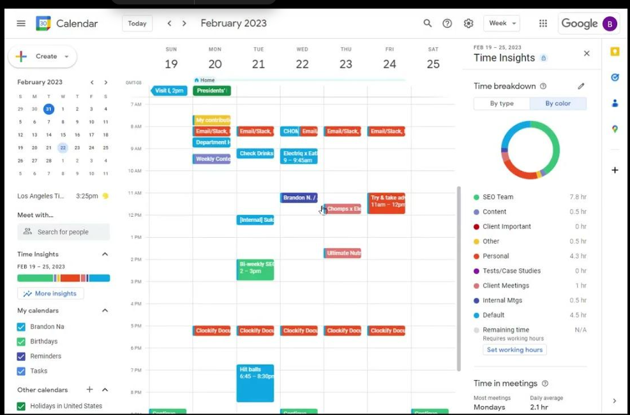

Description
Google Calendar is a cloud-based calendar application developed by Google that enables users to organize meetings, classes, personal events, reminders, and recurring schedules. It synchronizes automatically across web browsers and mobile devices, making it one of the most widely used scheduling applications worldwide.

Main Features
- Create and manage events.
- Recurring events.
- Calendar sharing.
- Gmail integration.
- Notifications and reminders.
- Cross-device synchronization.
- Time-zone support.

Similarity with Our Project
- Organizes schedules and events.
- Supports reminders.
- Integrates with Gmail.
- Displays daily, weekly, and monthly calendars.

Difference from Our Project
- Does not predict user energy levels.
- Does not analyze screen time.
- Does not detect burnout.
- Does not measure attention health.
- Does not personalize schedules using behavioral analysis.
- Does not automatically optimize task placement using a Decision Engine (VIKOR).
Official Website
https://calendar.google.com
Accessed on
16 July 2026

- Microsoft Outlook Calendar
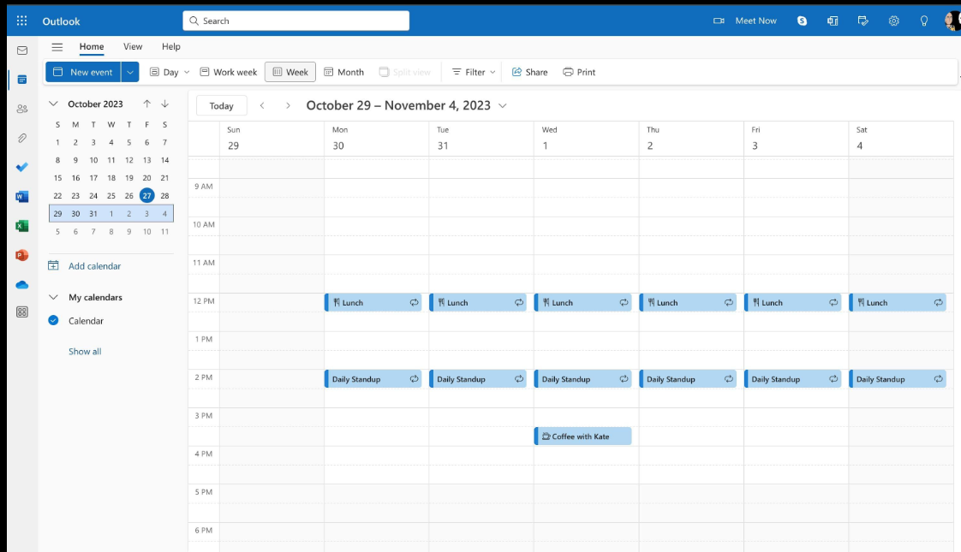

Description
Microsoft Outlook Calendar is Microsoft's scheduling platform integrated with Outlook Mail and Microsoft 365. It enables users to organize meetings, appointments, and events while maintaining synchronization with email communication.

Main Features
- Email and calendar integration.
- Meeting invitations.
- Shared calendars.
- Task reminders.
- Microsoft Teams integration.
- Mobile and desktop synchronization.

Similarity with Our Project
- Email integration.
- Calendar management.
- Reminder notifications.
- Meeting scheduling.

Difference from Our Project
- No automatic extraction of task priority using intelligent analysis.
- No fatigue prediction.
- No burnout detection.
- No attention-health monitoring.
- No intelligent decision-making engine.
- No adaptive scheduling according to physiological status.
Official Website
https://outlook.office.com/calendar
Accessed on
16 July 2026

- MyStudyLife
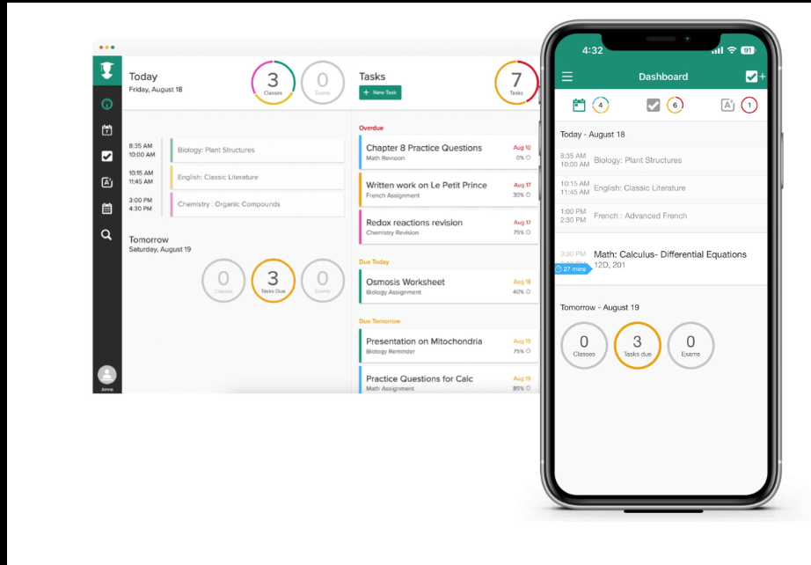

Description
MyStudyLife is a cloud-based academic planner designed specifically for students. It helps organize lectures, assignments, exams, and study schedules while synchronizing information across multiple devices.

Main Features
- Timetable management.
- Assignment tracking.
- Exam scheduling.
- Notifications.
- Offline access.
- Cross-platform synchronization.

Similarity with Our Project
- Student-focused scheduling.
- Assignment management.
- Exam reminders.
- Weekly timetable organization.

Difference from Our Project
- Does not analyze user behavior.
- No screen-time monitoring.
- No energy prediction.
- No burnout estimation.
- No adaptive scheduling.
- No intelligent decision engine based on multiple criteria.
Official Website
https://mystudylife.com
Accessed on
16 July 2026

- Todoist
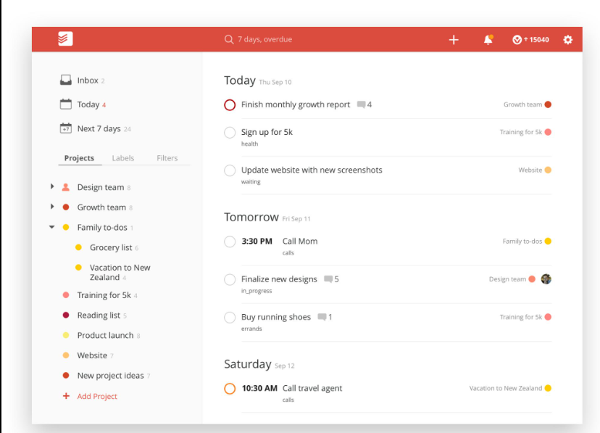

Description
Todoist is a productivity and task-management application that allows users to create projects, prioritize tasks, assign deadlines, and monitor daily productivity using a simple and intuitive interface.

Main Features
- Task management.
- Priority levels.
- Labels and filters.
- Project organization.
- Productivity tracking.
- Calendar integration.
- Cross-platform synchronization.

Similarity with Our Project
- Task organization.
- Priority assignment.
- Deadline management.
- Reminder notifications.

Difference from Our Project
- Does not estimate cognitive performance.
- No physiological modeling.
- No burnout prediction.
- No intelligent event extraction from emails.
- No behavioral personalization.
- No dynamic rescheduling using multiple health-related criteria.
Official Website
https://todoist.com
Accessed on
16 July 2026

5. TickTick
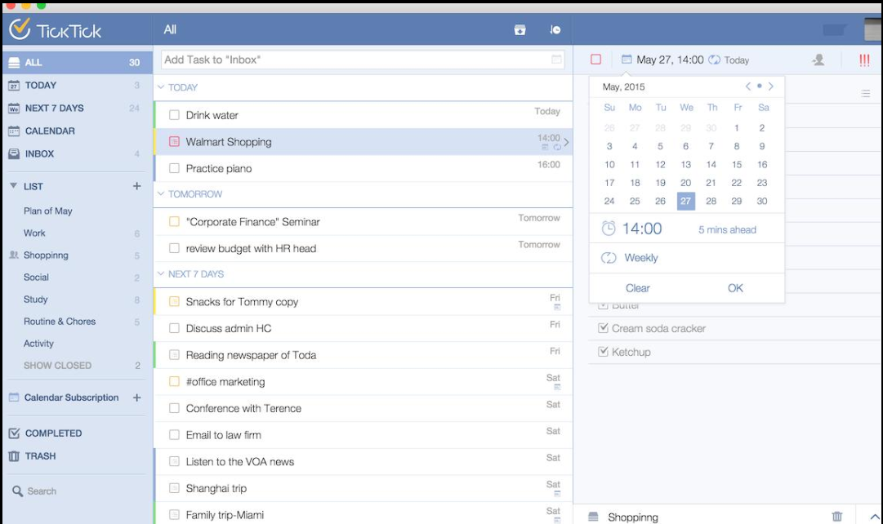

Description
TickTick is a task management and productivity application that combines to-do lists, calendars, reminders, habit tracking, and focus timers in a single platform. It is designed to improve daily organization and productivity.

Main Features
- To-do lists.
- Calendar view.
- Habit tracking.
- Pomodoro timer.
- Smart reminders.
- Cross-device synchronization.
- Task categorization.

Similarity with Our Project
- Daily task scheduling.
- Calendar organization.
- Reminder system.
- Habit management.
- Focus timer.

Difference from Our Project
- No AI-based scheduling optimization.
- No email event extraction.
- No screen-time analysis.
- No energy prediction.
- No burnout detection.
- No multi-criteria decision engine.
- No dynamic physiological rescheduling.
Official Website
https://ticktick.com
Accessed on
16 July 2026

- Microsoft To Do


Description
Microsoft To Do is a task management application developed by Microsoft that helps users organize daily activities, create to-do lists, set reminders, and synchronize tasks across Windows, Android, iOS, and the web. It integrates seamlessly with Microsoft 365 services.

Main Features
- Daily task planning (My Day).
- Task reminders.
- Due dates and recurring tasks.
- Task sharing.
- Outlook synchronization.
- Cross-platform support.

Similarity with Our Project
- Task management.
- Reminder notifications.
- Daily scheduling.
- Integration with Microsoft services.

Difference from Our Project
- Does not predict user energy levels.
- No burnout detection.
- No attention health analysis.
- No email event extraction using NLP.
- No dynamic schedule optimization.
- No multi-criteria decision-making engine.
Official Website
https://to-do.microsoft.com
Accessed on
16 July 2026

- Notion Calendar
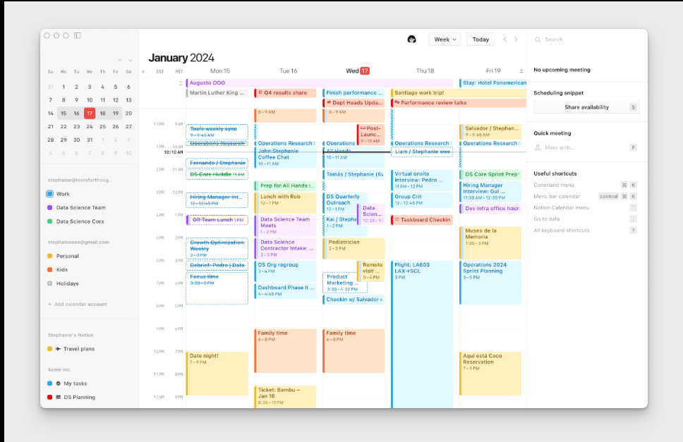

Description
Notion Calendar is a calendar management application that integrates scheduling with Notion workspaces. It enables users to organize meetings, deadlines, and projects while synchronizing with Google Calendar for centralized planning.

Main Features
- Calendar management.
- Google Calendar synchronization.
- Meeting scheduling.
- Workspace integration.
- Event organization.
- Cross-platform support.

Similarity with Our Project
- Event scheduling.
- Calendar management.
- Deadline organization.
- Daily planning.

Difference from Our Project
- No intelligent scheduling optimization.
- No behavioral analysis.
- No physiological monitoring.
- No burnout prediction.
- No adaptive rescheduling.
- No personalized recommendation engine.
Official Website
https://www.notion.com/product/calendar
Accessed on
16 July 2026

- Any.do
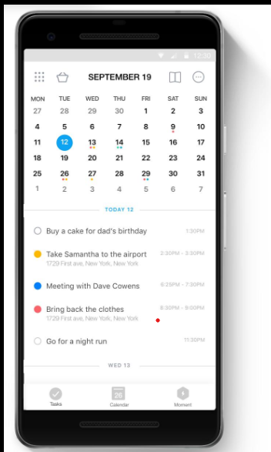

Description
Any.do is a productivity application that combines task management, calendar organization, reminders, and collaborative planning. It enables users to organize both personal and professional activities through an intuitive interface.

Main Features
- Task management.
- Calendar integration.
- Daily planner.
- Recurring reminders.
- Collaboration.
- Cross-device synchronization.

Similarity with Our Project
- Organizes tasks.
- Calendar scheduling.
- Reminder system.
- Daily planner.

Difference from Our Project
- Does not estimate attention health.
- No burnout prediction.
- No screen-time analytics.
- No intelligent event extraction.
- No physiological decision-making.
- No adaptive scheduling based on user condition.
Official Website
https://www.any.do
Accessed on
16 July 2026

- TimeTree
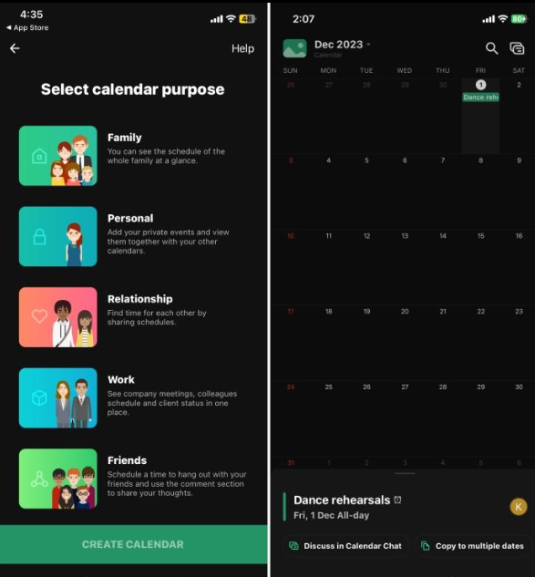

Description
TimeTree is a collaborative calendar application designed for families, students, and teams. It allows multiple users to share calendars, coordinate schedules, and communicate through comments attached to calendar events.

Main Features
- Shared calendars.
- Event comments.
- Reminder notifications.
- Multiple calendars.
- Cross-platform synchronization.
- Group scheduling.

Similarity with Our Project
- Calendar management.
- Event scheduling.
- Reminder notifications.
- Collaborative planning.

Difference from Our Project
- No intelligent prioritization.
- No behavioral monitoring.
- No fatigue estimation.
- No energy prediction.
- No decision engine.
- No adaptive scheduling.
Official Website
https://timetreeapp.com
Accessed on
16 July 2026

10. Structured
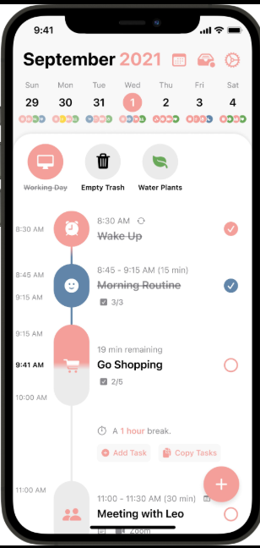

Description
Structured is a visual day planner that helps users organize daily routines through a timeline-based interface. It is designed to improve time management by providing a clear representation of daily activities and reminders.

Main Features
- Timeline-based schedule.
- Daily planning.
- Task reminders.
- Calendar synchronization.
- Recurring tasks.
- Cross-platform support.

Similarity with Our Project
- Daily scheduling.
- Task organization.
- Reminder notifications.
- Timeline visualization.

Difference from Our Project
- Does not analyze user behavior.
- No burnout prediction.
- No attention health monitoring.
- No screen-time analysis.
- No intelligent scheduling optimization.
- No adaptive rescheduling based on physiological conditions.
Official Website
https://structured.app
Accessed on
16 July 2026

11. Habitica
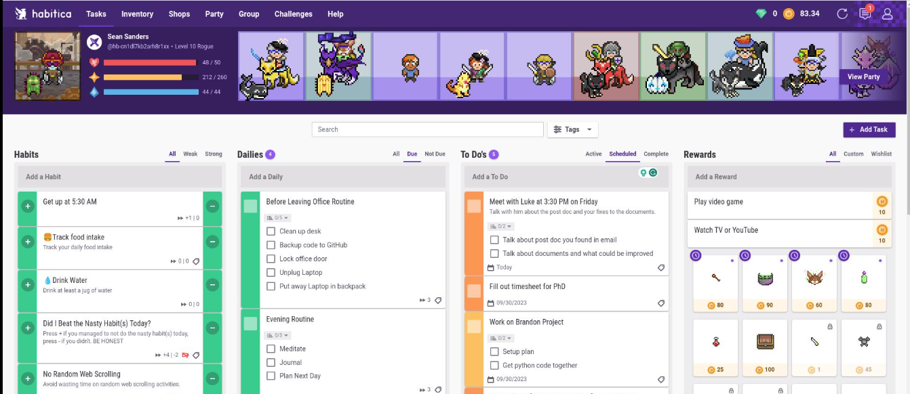

Description
Habitica is a gamified productivity application that transforms daily tasks and habits into role-playing game elements. Users earn rewards by completing tasks, building habits, and achieving personal goals. This approach increases motivation and encourages consistent productivity through game mechanics.

Main Features
- Habit tracking.
- Daily task management.
- To-do lists.
- Rewards and achievements.
- Progress statistics.
- Team challenges.
- Cross-platform synchronization.

Similarity with Our Project
- Organizes daily tasks.
- Tracks user habits.
- Encourages productivity.
- Supports long-term goal management.

Difference from Our Project
- Does not analyze attention health.
- No screen-time monitoring.
- No physiological state prediction.
- No burnout detection.
- No intelligent scheduling optimization.
- No AI-based decision engine.
Official Website
https://habitica.com
Accessed on
16 July 2026

12. Shovel
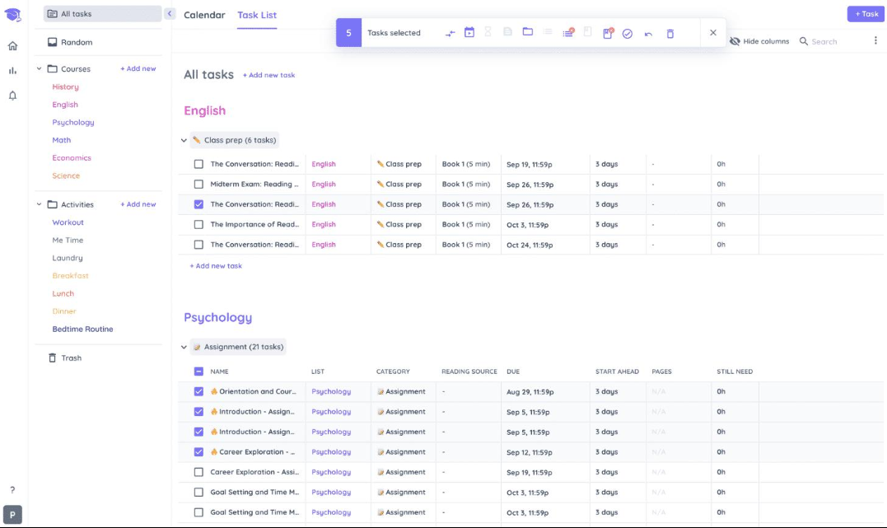

Description
Shovel is an academic planning application designed specifically for university students. It enables users to organize coursework, assignments, exams, and study hours while visualizing workload across semesters to improve time management.

Main Features
- Study planner.
- Assignment scheduling.
- Exam calendar.
- Workload visualization.
- Semester planning.
- Progress tracking.

Similarity with Our Project
- Academic scheduling.
- Study planning.
- Deadline management.
- Exam organization.

Difference from Our Project
- No email event extraction.
- No behavioral learning.
- No energy prediction.
- No burnout analysis.
- No adaptive scheduling.
- No intelligent multi-criteria decision-making.
Official Website
https://www.shovelapp.io
Accessed on
16 July 2026

13. Egenda


Description
Egenda is a homework planner developed for students to organize assignments, projects, quizzes, and exams. The application provides reminders and simple scheduling tools to help students keep track of academic responsibilities.

Main Features
- Homework management.
- Assignment reminders.
- Class scheduling.
- Exam tracking.
- Simple academic planner.
- Mobile accessibility.

Similarity with Our Project
- Student planner.
- Assignment tracking.
- Reminder notifications.
- Academic scheduling.

Difference from Our Project
- No intelligent scheduling.
- No physiological analysis.
- No screen-time monitoring.
- No attention analysis.
- No burnout prediction.
- No personalized schedule optimization.
Official Website
https://egenda.com
Accessed on
16 July 2026

14. Power Planner
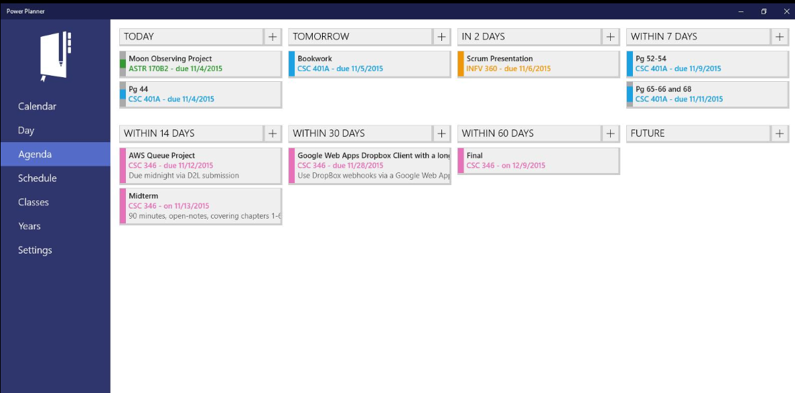

Description
Power Planner is an academic management application that enables students to organize courses, assignments, grades, exams, and semester schedules. It provides grade calculations and academic progress monitoring in addition to calendar planning.

Main Features
- Course management.
- Grade tracking.
- Assignment planner.
- Semester scheduling.
- GPA calculation.
- Calendar integration.

Similarity with Our Project
- Academic scheduling.
- Assignment management.
- Exam planning.
- Course organization.

Difference from Our Project
- No intelligent recommendation engine.
- No fatigue prediction.
- No behavioral analysis.
- No attention monitoring.
- No burnout detection.
- No adaptive rescheduling.
Official Website
https://powerplanner.net
Accessed on
16 July 2026

15. iStudiez Pro
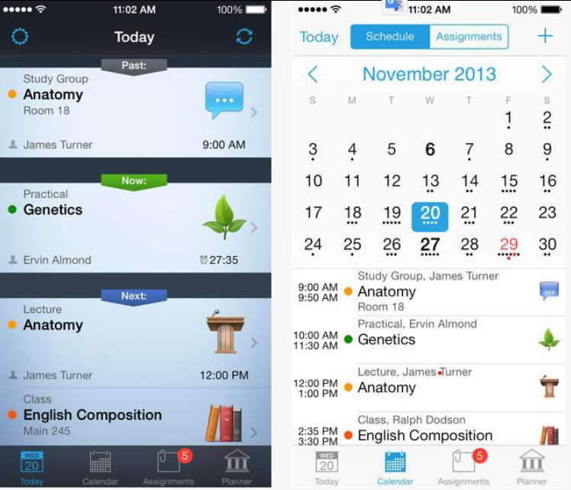

Description
iStudiez Pro is a comprehensive academic organizer that helps students manage classes, homework, exams, grades, and study schedules. It offers synchronization across Apple devices and provides a centralized platform for academic planning.

Main Features
- Timetable management.
- Homework planner.
- Exam scheduling.
- Grade tracking.
- Notifications.
- Device synchronization.

Similarity with Our Project
- Study scheduling.
- Assignment organization.
- Academic calendar.
- Reminder system.

Difference from Our Project
- No intelligent email parsing.
- No energy prediction.
- No burnout detection.
- No screen-time analysis.
- No adaptive scheduling using user health.
- No multi-criteria decision engine such as VIKOR.
Official Website
https://istudentpro.com
Accessed on
16 July 2026

Description of Our Proposed System
Our proposed system is an AI-powered Intelligent Decision Support System designed to provide personalized and adaptive scheduling rather than simple calendar or task management. Unlike existing applications that primarily focus on organizing events, assignments, or reminders, our system integrates multiple intelligent modules to analyze both the user's tasks and personal condition before generating an optimized schedule.
The system automatically extracts events from emails using Natural Language Processing (NLP), predicts the user's energy level, evaluates attention health, estimates burnout risk, and analyzes screen-time behavior. It also learns the user's preferences through Machine Learning to continuously improve scheduling decisions. Based on these factors, the system employs the VIKOR Multi-Criteria Decision-Making (MCDM) algorithm to prioritize tasks and generate the most suitable schedule. Furthermore, it supports dynamic rescheduling, allowing the schedule to adapt automatically whenever new events or unexpected changes occur.
Compared with the reviewed applications, our proposed system does not simply organize tasks or display calendar events. Instead, it intelligently decides what should be done, when it should be done, and why that time is the most appropriate, considering the user's physical, cognitive, and behavioral state. This comprehensive integration of email understanding, health-aware scheduling, machine learning personalization, decision support, and adaptive rescheduling distinguishes our system from existing scheduling and productivity applications.

